Hello World

# Create maven project

1. File-> New-> Other
2. Select Maven -> Maven Project
3. Next
4. Next
5. Select Group Id org.apache.maven.archetypes and Artifact Id maven-archetype-quickstart
6. Next
7. Group Id com.corespring.learning
8. Artifact Id 01_HelloWorld
9. Finish
10. Our project looks like

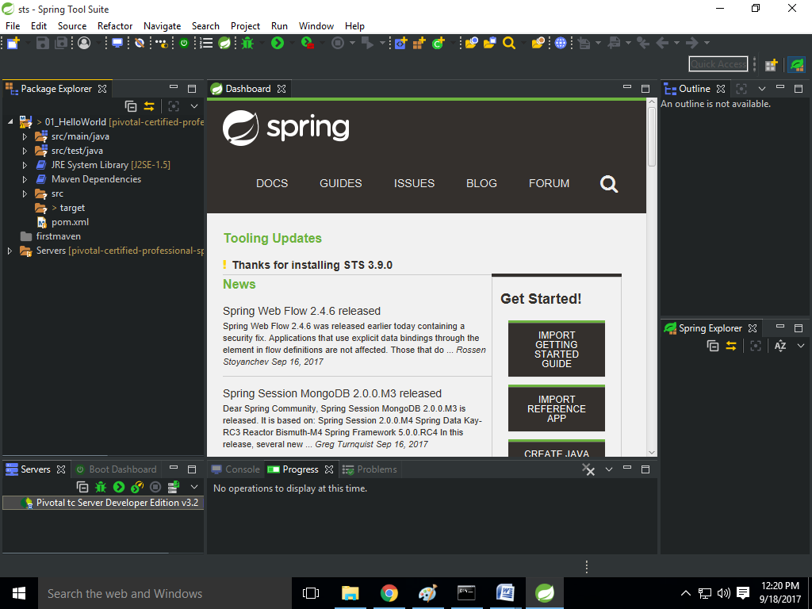

# Add new dependencies

You should follow the first maven project tutorial steps for add dependencies. Here only dependency name is described.

1. Spring-core 4.2.9.RELEASE
2. spring-beans 4.2.9.RELEASE
3. spring-context 4.2.9.RELEASE
4. Then click on save menu and it will build the workspace
5. After build we will found the jars at Maven Dependencies folder
6. Create Patient Class
7. Add Speak Method to Patient Class

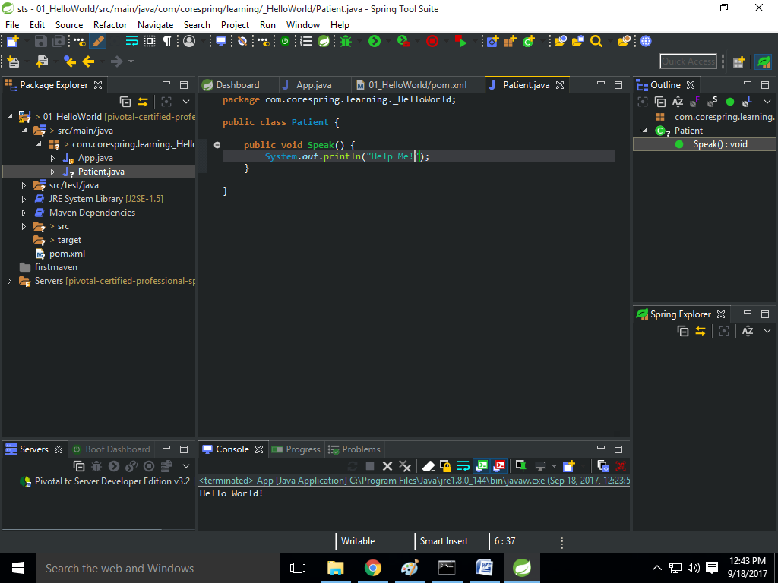

1. Use Speak method at App.java class

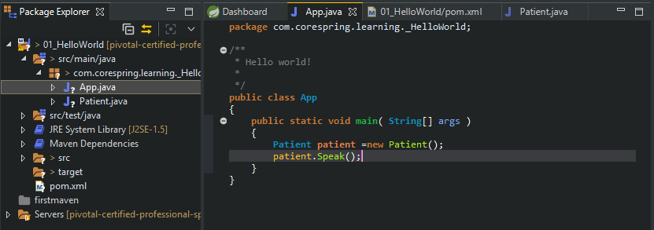

1. Create Spring Bean Configuration file from new menu

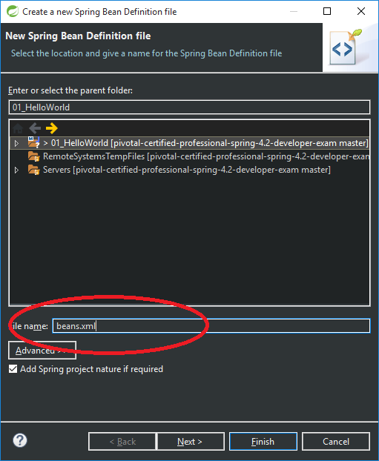

1. Define Patient Class Bean
   1. Double click beans.xml

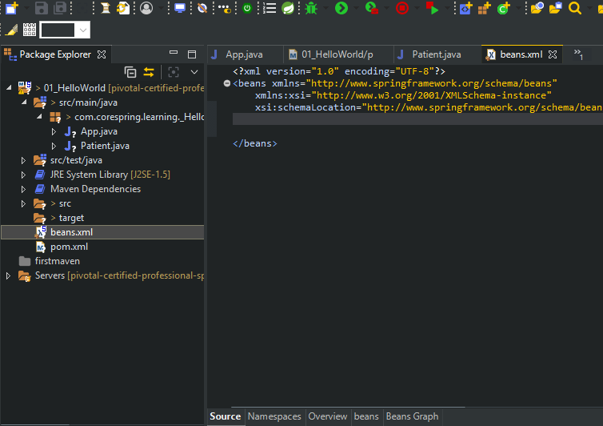

* 1. Select beans tab

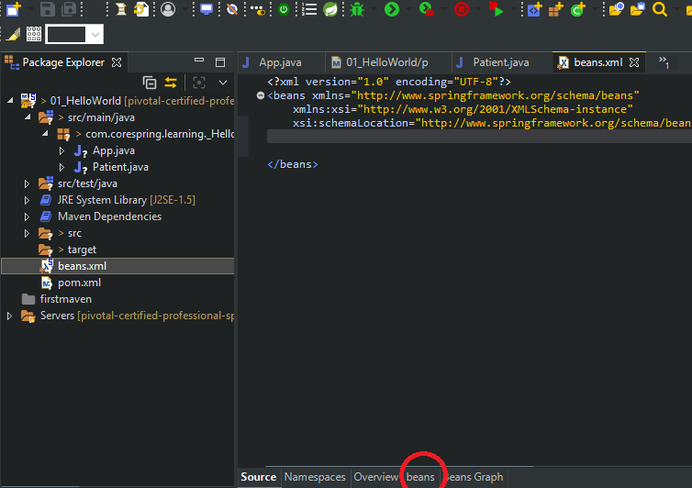

* 1. Add new bean

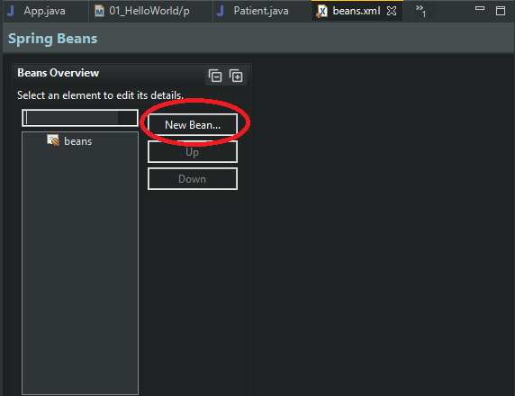

* 1. Id= patient (We can define anything)
  2. Class= Patient (Class Name)

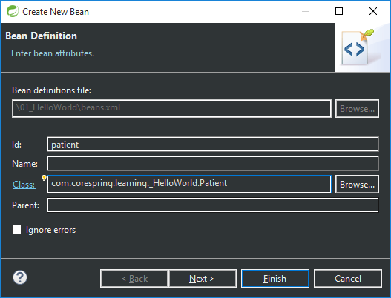

* 1. Finish

1. Now we want to load the beans.xml file from our App.java class

